
Activity 2.2.2 Shed Cost Estimate

Introduction
Before you begin a project, you should know how much it is going to cost. You must ensure that you have enough money to finish the project. You may not even begin the project if you determine that it is too expensive. Large construction firms have employees who work exclusively on estimating project costs. Estimators work to allow companies to bid for job acquisition and predict costs and time required for completion. No job should be started without at least a general estimate. These estimates are used to plan work and resources.

Equipment
- Building Materials Cost Estimate template
- Engineering notebook
- Calculator
- A2 – Example Utility Shed Framing Drawing
- Internet access, phone and phone book, and/or building materials data

Procedure
In this activity you will determine the estimated material cost to build the example utility shed. To do this accurately, you will use the elevation views of the framing for the building.

The prices found in the Building Materials Cost Estimate template may differ from those of your region and may need to be updated. Local prices can be obtained by using the phone, Internet, or current advertisements.

Be aware that this cost estimate assumes that you will build the shed yourself. Only material costs are included. Most building project cost estimates would also include the cost of labor to install each component which can significantly increase the cost of construction.

As you account for each framing member, use a highlighter or colored pencil to shade each member included in the cost estimate. Always round up to the next whole number when calculating quantities of materials.

- Open the Building Materials Cost Sheet spreadsheet.
Floor
- Enter quantities and unit costs for concrete, rebar, and forms found during Activity 2.2.1. Total cost will calculate automatically.
Walls
NOTE – For the purposes of this activity, the interior walls will be omitted.

- Using drawing A2 – Example Utility Shed Framing Drawing, calculate the quantities of all framing members needed to build the walls. The Sample Wall Framing Plan below may help you identify the various framing members needed. Obtain local prices (or use those provided) for all framing and siding materials for the shed in the Building Materials Cost Estimate. You may choose to change the type of siding material used.

SAMPLE WALL FRAMING PLAN
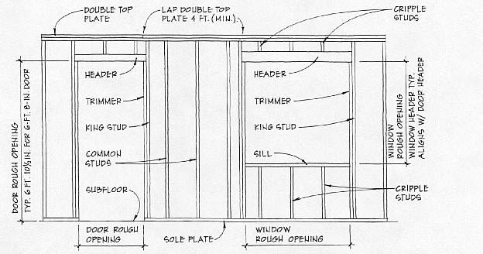

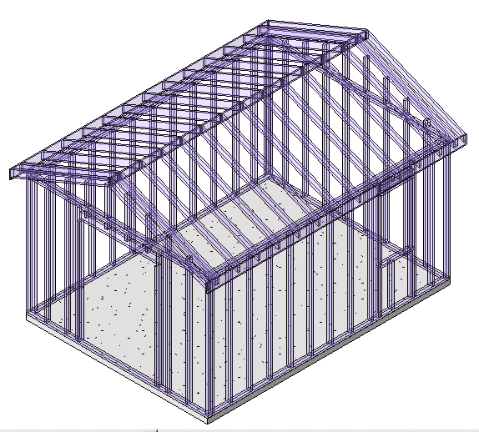

Studs are spaced 16 in. on center. Be sure to plan for headers, trimmer studs, king studs, and cripple studs as shown in the Sample Wall Framing Plan above. Notice in drawing A2 – Example Utility Shed Framing Drawing that headers are double members and that an extra top plate is installed at the top of each gable end wall just under the double rafter.

Roof
- You may use the 3D modeling software to obtain the surface area of the roof as shown below. Use the surface area value to calculate how many squares of shingles, sheets of sheathing (4ft x 8ft), and rolls of roofing felt are needed (1 square of shingles = 100 ft² = 3 bundles).

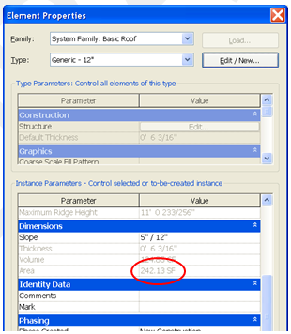

- Account for the total linear feet of fascia. Fascia boards should be installed around the entire perimeter of the roof including the sloped edges on the gable ends.
- Drip edges will be installed only at the sloped lower edges of the roof, not on the gable ends. Drip edges are available in 10 ft sections.
- Account for all rafters. These should be spaced a maximum of 16 in. on center, except that double rafters are used over the gable end walls.

Openings
- Enter the cost of each door and window in the unit cost column of the Building Materials Cost Sheet.
Check
- Check to make sure that all building components have been included in the cost estimate. If not, add rows within the cost estimate to include the missing items.
- After finding a total cost for construction using standard materials, brainstorm ways to save money and resources on this project. Make notes and sketches of your ideas in your engineering notebook.

Conclusion
- What category costs the most to build – the walls, floor, roof, or door/windows?

- In what category do you find the most waste?

- How could you lower the cost of building this structure without sacrificing quality?

